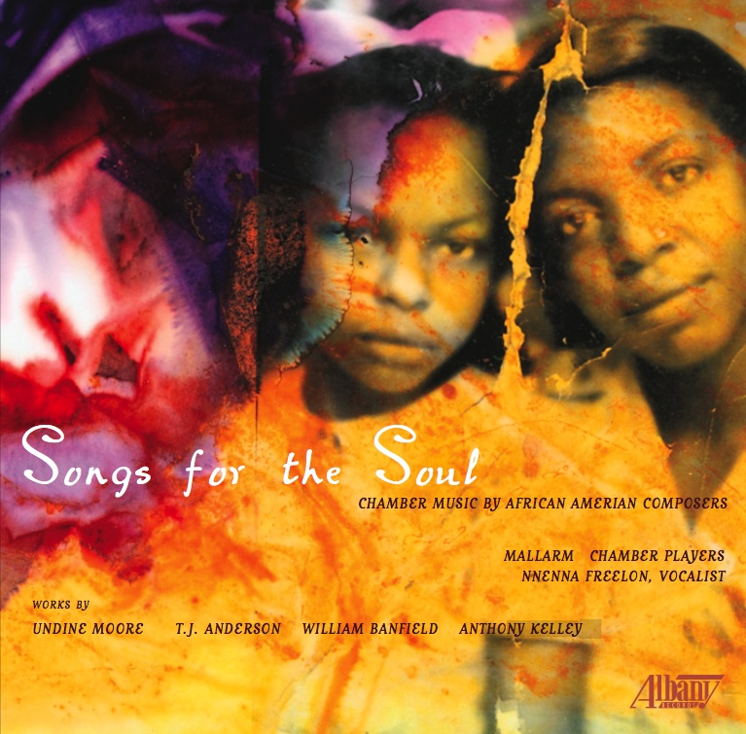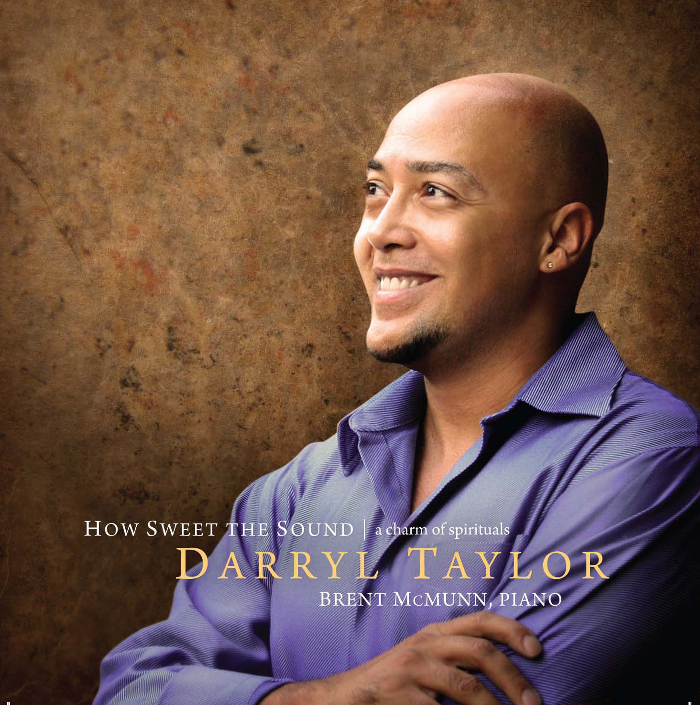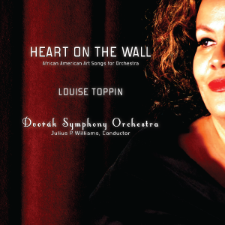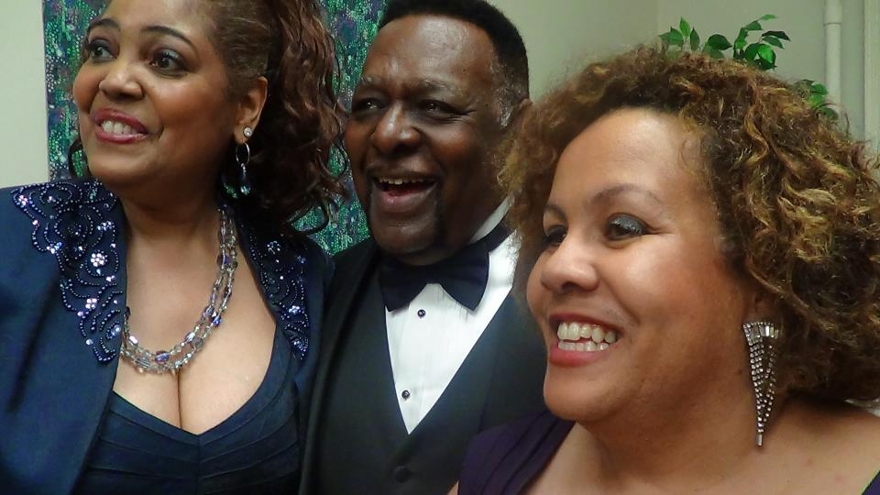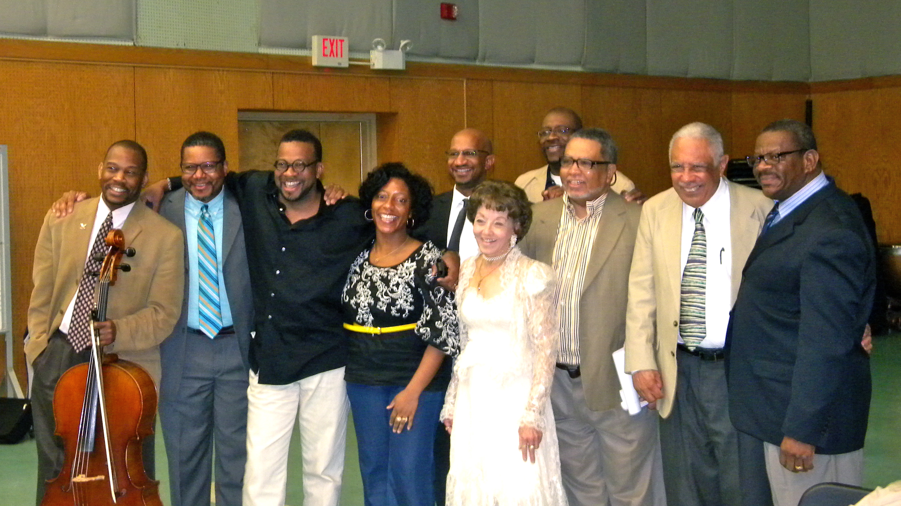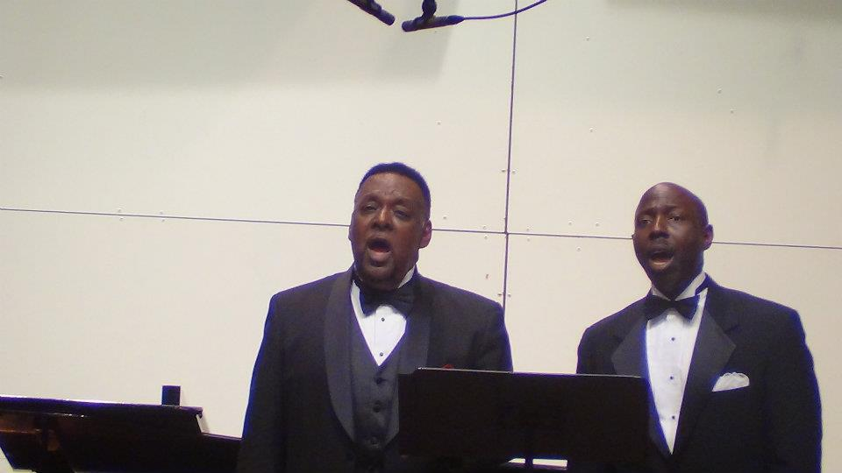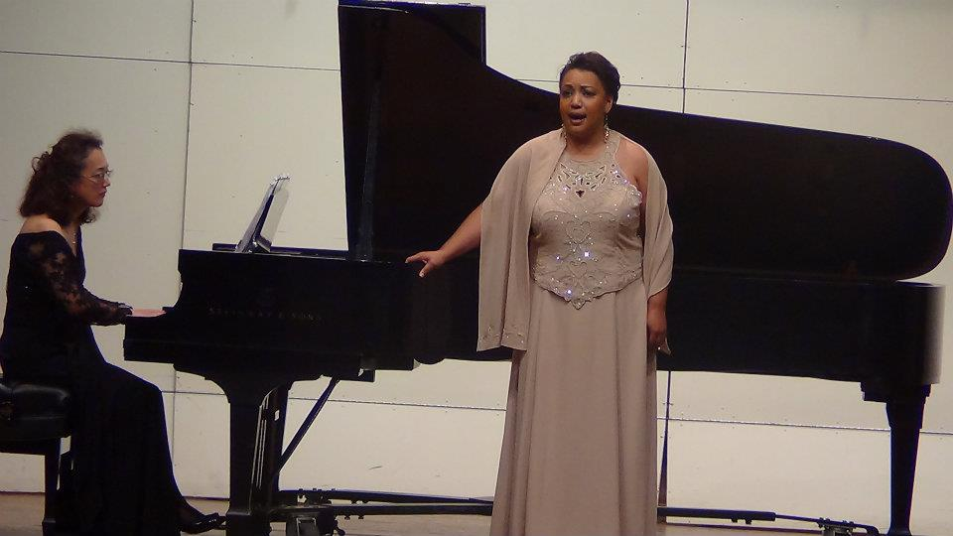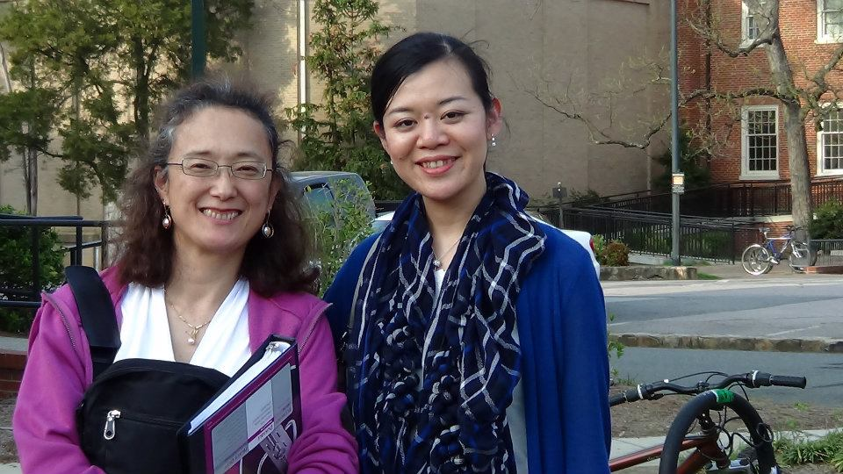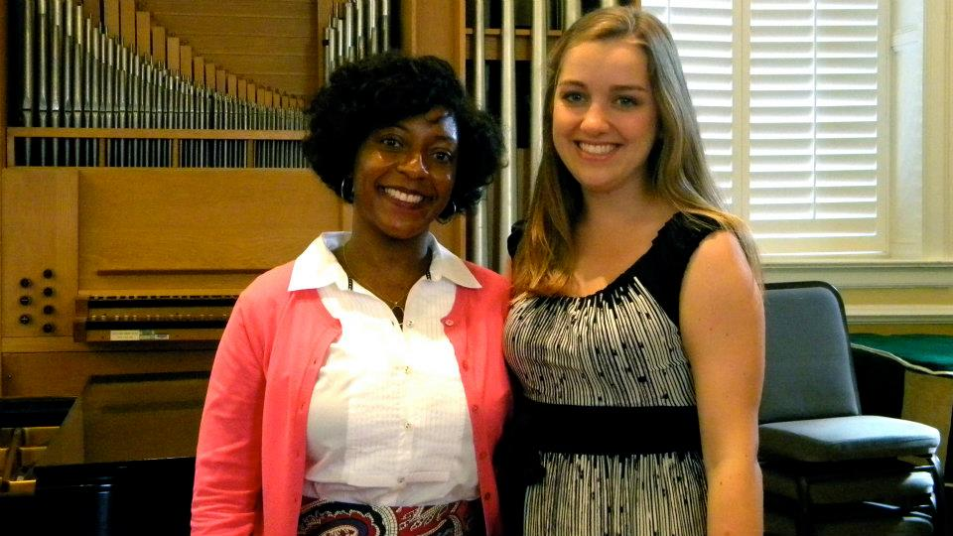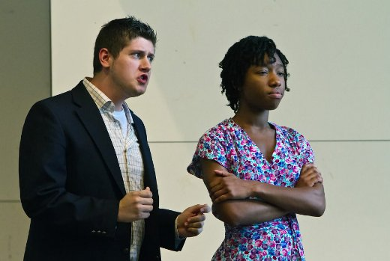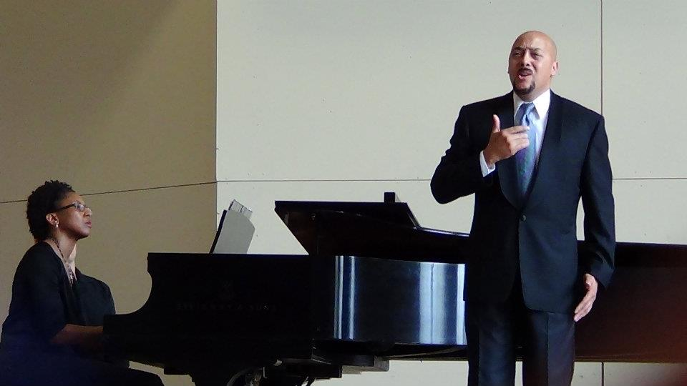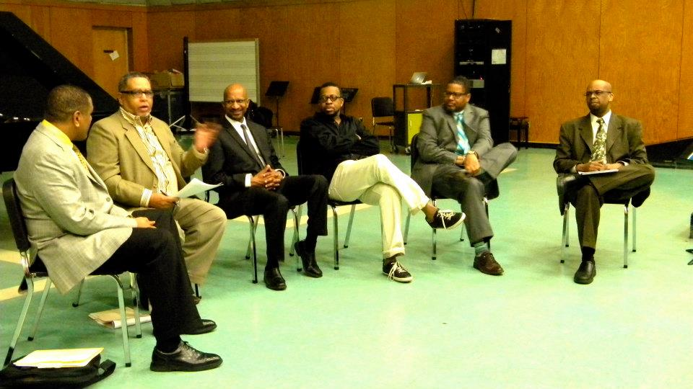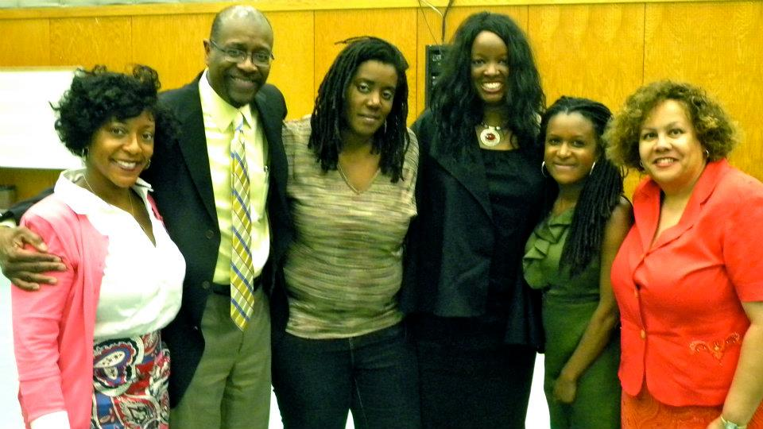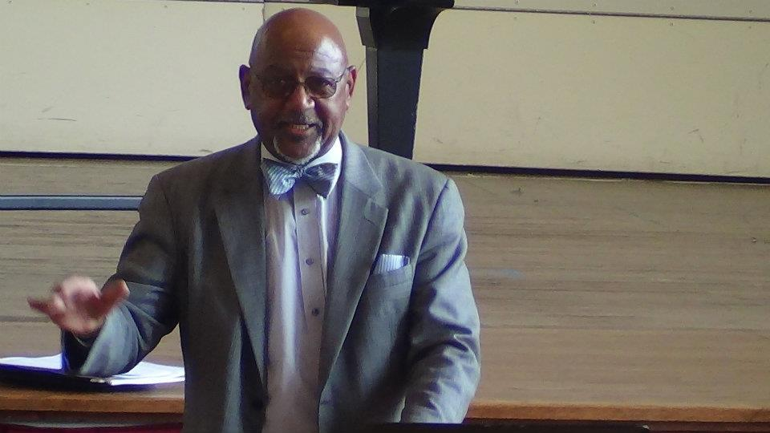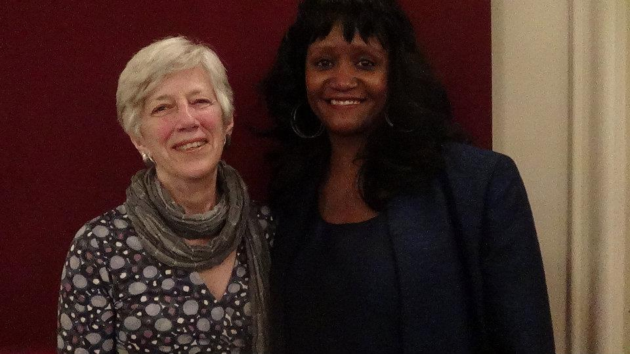

Heart on the Wall

African American Art Songs with Orchestra*.*

*Louise Toppin, soprano; Julius Williams, conductor; Dvorak Symphony, Orchestra*

How Sweet the Sound

A Charm of Spirituals

*Darryl Taylor, countertenor; Brent McNunn, piano*

Songs for the Soul

Chamber works by African American composers

*Mallarme Chamber Players; Nnenna Freelon; Composers TJ Anderson, Undine Moore, Anthony Kelley, William Banfield*

This past March we held the Videmus @25 Festival, celebrating 25 years of producing and illuminating classical music of women, African American, and under-represented composers. Held at the University of North Carolina at Chapel Hill, the festival showcased masterclasses, concerts, recitals, choral clinics, lectures, and interviews by renowned musicians such as Marquita Lister, Darryl Taylor, T.J. Anderson, Uzee Brown, Roland Carter, Aldolphus Hailstork, William Banfield and Herbie Hancock. The masterclasses and choral clinic offered allowed current college students a rare opportunity to perform for seasoned professionals and receive constructive feedback, helping them to further their own performance and educational endeavors. One highlight of the weekend was George Shirley’s interview of the Southern Divas: Martha Flowers, Leona Mitchell, and Hilda Harris. Mr. Shirley asked questions that allowed us to take an adventure through the lives of these influential and remarkable performers. A transcript of this conversation can be found [HERE](http://operalively.com/forums/content.php/488-A-Conversation-with-Legendary-Southern-Opera-Divas).

# Videmus @25 Festival

*Reflecting on the Past, Reaching Toward the Future*

Website: [www.videmus.org](http://www.videmus.org)

Email: Videmus1986@gmail.com

Address: 4710 Regency Dr. Durham, NC 27713

Phone: 919-294-6902

Continued on Page 2

Videmus Records Releases

Heart on the Wall, 2011

How Sweet the Sound, 2010

Songs for the Soul, 2010

### Record Releases

Contact us!

Fall Newsletter

Videmus

Fall 2012

Videmus

VIDEOS

OPERA LIVELY ARTICLE

CVNC REVIEW

#### Links for Videmus @25 Festival

The Festival also provided a special evening Gala of opera and song with renowned performers, such as George Shirley, Leona Mitchell, Marquita Lister, Louise Toppin, Anthony Turner, Sam McKelton, Robert Honeysucker, Laura English-Robinson, Daniel Washington, Patricia Miller, Lori Hicks, Donal Fox, Noriko Yasudo, and Patrick O’Donnell.

## Videmus @ 25 Festival

Videmus is a non-profit organization dedicated to the promotion of the music of women, African American, and under-represented composers through concerts, recordings, educational programs, and scholarship. If you would like to join the Friends of Videmus, please visit us at [www.videmus.org](http://www.videmus.org). Thank you for your support!

About our organization

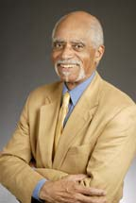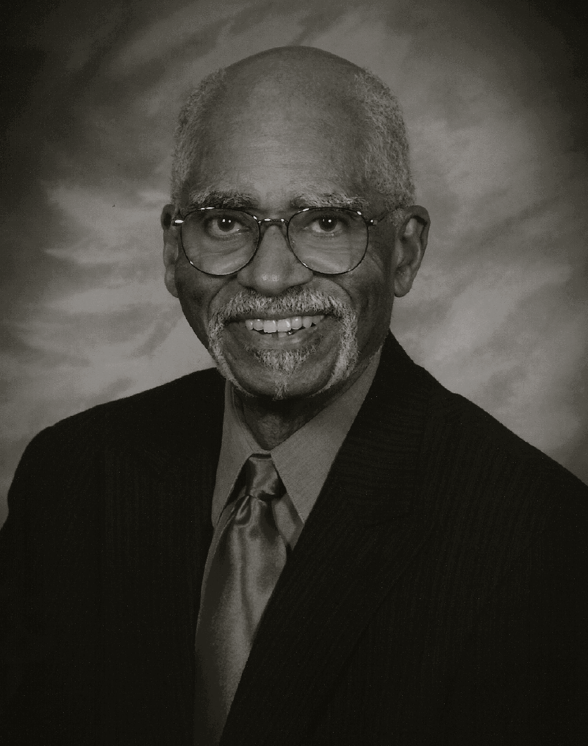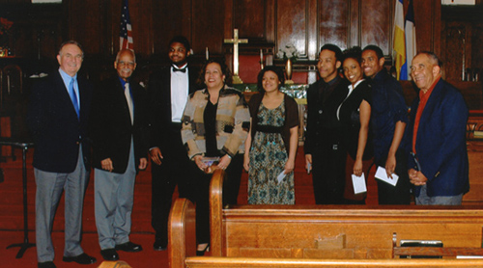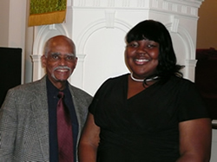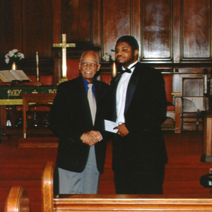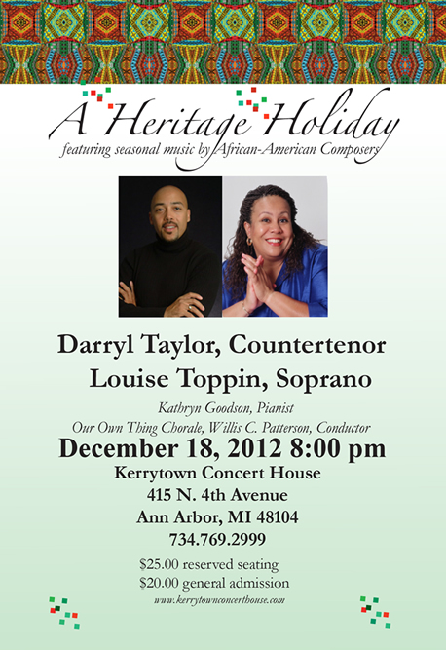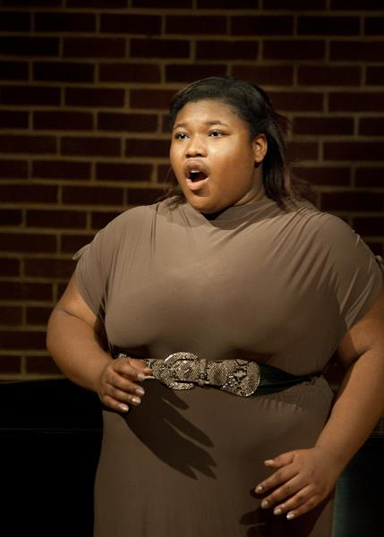

Sponsored by:

SmithJackson Arts ([www.smithjacksonarts.com](http://www.smithjacksonarts.com)) & Videmus

**Pictured above (from left to right) are the finalists and judges of the**

**2012 George Shirley competition:** John Zaretti, George Shirley, Philip Lee, Louise Toppin, Demetra Hawkins (2nd prize), Keith Walls (fourth prize),

Keira Bell and Robert Mock (tied for third prize), Willis Patterson.

**Pictured to the left is the 2012 First Prize Winner: Philip Lee**

**Pictured to the right is the 2011 First Prize Winner: Corinthia Sims**

##### The George Shirley African-American Art Song and Operatic Aria Competition is open to singers of all races and ethnicities, this competition focuses solely on vocal compositions written for the recital or operatic stage by composers of African-American descent. If you are interested in supporting aspiring young singers with tax-deductible donations to: The George Shirley

##### African American Art

##### Song and Operatic Aria Competition.

### The George Shirley African-American Art Song and Operatic Aria Competition

### January 26, 2013

### Wayne State University

### Detroit, Michigan

* Margaret Bonds and the Women of the Chicago Renaissance, March 2-3, 2013 at UNC-Chapel Hill and North Carolina Central University. Keynote speaker: Dr. Rae Linda Brown, Vice President of Undergraduate Education and Professor of Music, Loyola Marymount University
* Upcoming recording of the Second Book of Etudes of Leslie Adams by Thomas Otten.
* Videmus African American Summer Music Institute. Look for future details.

### Upcoming Events…

##### Bridges Award Update:

##### 2012-2013 Recipient

##### Kaswanna Kanyinda

A current junior in college and resident of Raleigh, North Carolina, she hopes to obtain a Bachelor of Music degree in Vocal Performance from the University of North Carolina at Chapel Hill. Ms. Kanyinda, a student of Dr. Louise Toppin, recently sang the mezzo-soprano role in UNC Chapel Hill’s Opera production of *Highway One* by William Grant Still, sang the World Premiere of “I Walk” composed by Trevor Weston for the Videmus Festival, sang the National Anthem for President Obama’s speech at UNC, sang the role of the Second Lady in *The Magic Flute* in several cities in Italy as a part of the Amalfi Coast Music Festival and was selected to sing as a part of the Memorial Service for UNC President William C. Friday. Ms. Kanyinda hopes to continue to develop her operatic career by pursuing a Masters degree in performance after graduation from UNC.

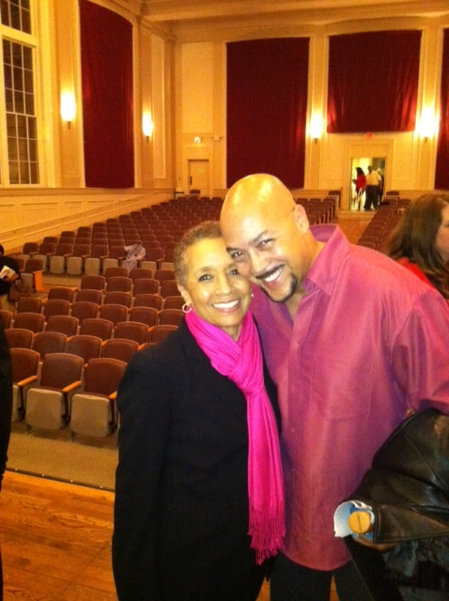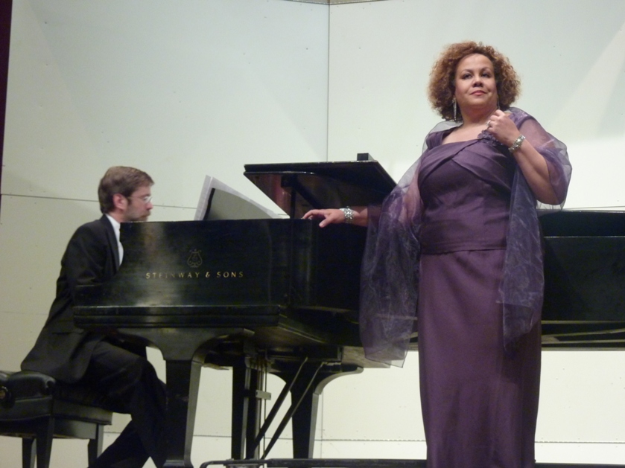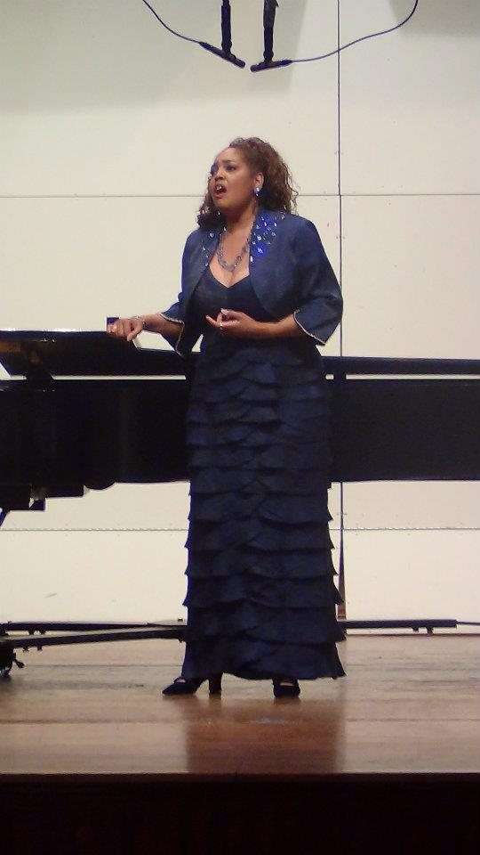

We thank you for the support of Videmus by incredible artists, composers, scholars and students during the past 25 years! You have sustained us by your attendance at programs and purchasing our products. If you would like to help us expand our program offerings, please consider making a tax deductible donation to support the Bridges Award, the George Shirley African American Art Song and Opera Competition or any of our other programs. Come visit the competition in Detroit January 26, 2013 or join us in North Carolina for a celebration of the centennial of the birth of composer Margaret Bonds at the University of North Carolina, March 2-3, 2013. With our thanks!

Louise Toppin, Director

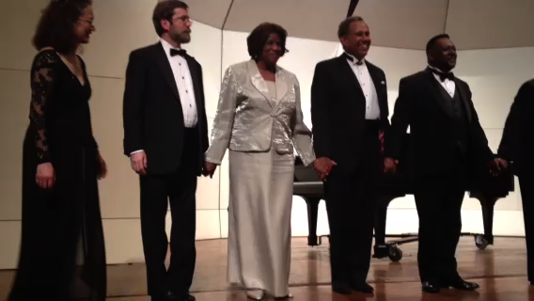

Videmus

4710 Regency Drive  
Durham, NC, 27713

Videmus @25 Festival

Thank you!

Fall 2012

Videmus